Information Systems Assignment

(6G4Z1103)

Final Submission

**Alexander Harrison (17080341)**

**Lewis Frater (17081955)**

**Callum Flanagan (17028406)**

**Rebecca Clarke(17032866)**

**Antreas Christofi(17083606)**

2017-2018

# 

# 

Contents

**Introduction** **4**

**Part 1** **4**

Introduction 4

Description of the problems with the current paper based system at Ray’s Rentals 4

System requirements for a proposed new computerised database system 5

What data enquiries and management reports are and the different types of management reports that are used 5

Useful data enquiries and management reports for Ray’s Rentals 6

Data Needed 6

Bike Records (Figure 1 below) 6

Data enquiries 7

Stock Report 8

Damage Report/Maintenance Report 8

Exception Report 8

Financial/Customer Reports 8

Analysis Report 9

Key Target Reports 9

Conclusion 9

**PART 2** **9**

Use case diagrams 11

Top down ERD 19

Appendix A - Bike Record 19

Appendix B - Rental Record 20

Bottom up ERD 20

Finalised ERD 21

Parts to order 21

Order to supplier 21

Supplier to bike 21

Bike to Maintenance history 21

Bikes to manufacturer 21

Bikes to dealer 21

Bikes to rental 22

Rental to customer 22

**PART 3** **22**

Amended ERD 22

Data Dictionaries 23

Table : Customer 23

Table : Rental 23

Table : Bike 24

Table : Dealer 24

Table : Manufacturer 25

Table : Maintenance History 25

Table : Parts 25

Table : Order Parts 26

Table : Supplier 26

Table : Order 26

SQL Database Tables (With Insert Statements) 27

Create and insert Statement for customer, manufacturer, dealer and bike 27

Create and insert statement for Maintenance, rental, supplier and parts 27

Create and insert statement for order and order_parts 28

Drop Tables 28

SQL Queries 29

Lewis’s Queries 29

Alex’s Queries 29

Callums Queries 30

Andreas Queries 30

Rebecca’s Queries 31

Commentary 33

[Lewis Frater  
Part 3 was interesting because we finally got to implement our ERDs within SQL. Writing the SQL code was quite tricky at first as it was a new language to learn. Putting foreign keys into the tables was a trial and error process as it turned out the order tables are created mattered significantly. This was the initial stumbling block we came across as a group.](#_vok9q6w9r7ym) 33

Alexander Harrison 33

Callum Flanagan 33

Rebecca Clarke 33

Andreas Christofi 34

**Project Conclusions** **34**

Rebecca Clarke: 34

Alexander Harrison 34

Lewis Frater 34

Callum Flanagan 35

Andreas 35

**Referencing List** **35**

**Bibliography List** **35**

**Appendices** **36**

Appendix A: Piazza report 36

Appendix B: Presentation Slides 40

# 

# 

# 

# 

# 

# 

# 

# 

# 

# 

# 

# 

# 

# 

# 

# 

# 

# 

# 

# Introduction

This report is our full report on the work we have done for Ray’s Rentals and implementing a new data management system for him. We have discussed the problems with the current type of system he has, how to improve this system and what reports he could use within the system. We then discussed how we would create this system and how it would look. Following that we then created the system and made some queries to show Ray some examples of what he can do with the system. Finally, we then reported this all back to Ray by using a presentation.

# Part 1

## Introduction

This report is going to cover Ray’s Rentals [RR] and the problems with his current system, how to improve his current system, what data enquiries and management reports are and how RR can use them. This report will take the approach of identifying the current problems with the system, outlining the requirements for a new system and how RR can use these.

### Description of the problems with the current paper based system at Ray’s Rentals

There are many problems with the current paper based system at Ray’s Rentals.

The first problem is that there is no readily available backup unless written out again which therefore means extra storage space is needed to keep these backups, as RR currently does not file these paper based copies away as they sometimes get lost. Another problem is that paper based systems can be easily damaged by natural disasters. Paper based copies can need changes, these need to be done manually meaning that records can look unprofessional, unlike, computer based systems where you can change data very quickly without an issue of it being unprofessional.

The security of the data can be compromised with a paper based system, this is because you can't easily lock files away without having filing cabinets, having filing cabinets will cost RR money. This system of security for files isn't very secure. Having a database would help, you could encrypt it, and it takes up less space plus it can be easily backed up.

The data is difficult to analyse so you can't predict trends and if your business is doing well or not. Being able to analyse the data allows for you to make a business strategy, such as if a certain type of bike is selling, you can work on selling that particular bike and you can find out why the other bikes aren't selling.

Information may get lost if not filed away properly. When records get lost this results in RR not being able to fulfil the customers’ orders. Paper based copies may be hard to read due to handwriting or damage such as stains, or general wear and tear.

It may take a long time to search through the records to find one specific booking or customer details as they aren't filed correctly and have to be sought through manually. This means it can become a time-consuming process, resulting in the business losing time and money.

Having a paper based system also means you have to buy huge amounts of paper and other office supplies so that you can continue to use the system, therefore costing the company more money.

# 

### System requirements for a proposed new computerised database system

The database system [DBS] must be able to record, store and search for data efficiently.

It must be able to record new entries into the database due to the acquisition of new bikes as well as keep track of all current bike’s maintenance records. Due to the disposal of hire bikes, data must be able to be deleted from the system when it is no longer of use.

The [DBS] must be able to solve end-user queries such as: displaying bike records and all the details within the bike records in a user-friendly and straightforward manner. It is convenient for [RR] if the [DBS] analysed and produced reports so business strategy can be changed accordingly, in response to trends and frequent occurrences.

For a reservation, a check must be done to see if the requested bike is available. If it is, details must be inputted into a rental record, which records the date, customer name, address, phone number as well as bike class and size.

The [DBS] must keep an up to date version of the bike hire list for general enquiries by customers. A part inventory list and ordering system is a must, so [RR] can keep track of repairs effectively.

## What data enquiries and management reports are and the different types of management reports that are used

Data enquiries are assignments which are responsible for collecting information from the customers with the purpose of being used in the process. In addition, they can accept and process many requests for data so they can save each piece of information to the right place (folder, database, etc). In RR case, data enquiries collect the details (name, address, postcode, telephone) of every new customer who wants to rent a bike or buy cycling accessories via the shop’s site, process the customer’s choice for payment, then sorts every detail in the right folder and saves it.

“Management Reports [MR] are used to refer what a manager can manage in a Company. MR’s are now about what a manager should be managing and not about what he can (T. Jackson,2016)”. MR are the systems that have a (sometimes) vital role for a company’s smooth operation, as their role is to collect every possible but useful detail that the company’s managers need to run the business, avoid leaving behind anything that might be useful and “help on making predictions about the future growth and profitability of the company (S. King (2016)”. These details are really useful for the financial managers too, since they can get gathered from a variety of sources and end up in a single system.

In RR shops report are used many different types of management reports are used, such as:

* Key Targets report
* Exception Report
* Analysis Report
* Financial/Customer Report
* Damage/Maintenance report

These are discussed in depth in the following part.

## Useful data enquiries and management reports for Ray’s Rentals

### Data Needed

The data required for the database system entails:

#### Bike Records (Figure 1 below)

1. Classification/Type (Mountain, Road, Tandem)
2. Bike ID (Unique string of numbers assigned to each bike)
3. Manufacturer (Name, Address, Postcode, Telephone)
4. Purchase (Date, Price)
5. Sizes (Large Male, Standard Male, Small Male, Standard Female, Child)
6. Model
7. Suppliers (Name, Address, Telephone)
8. Disposal Details
9. Sale (Date, Price)

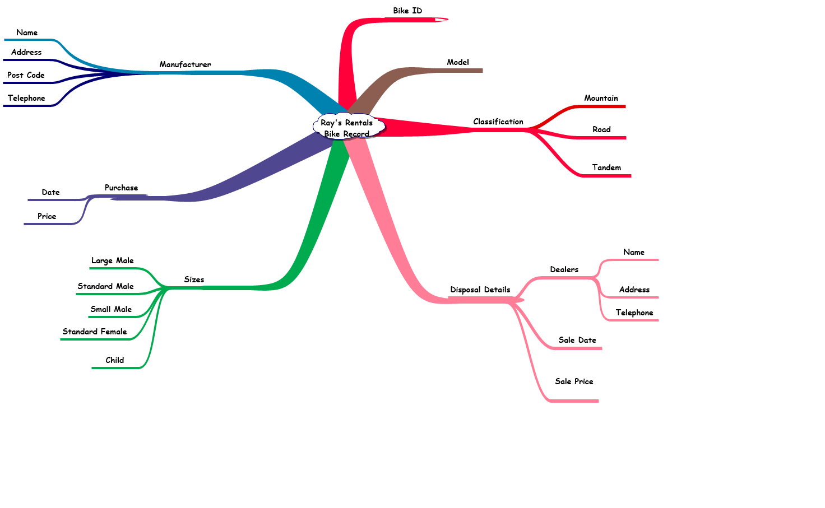

Figure 1

Rental Records (Figure 2 below)

1. Bike (Bike ID, Bike Name, Classification/Type, Size)
2. Rent (Rent Price, Date, Time Out, Time Back: Due and Actual)
3. Customer (Name, Address, Postcode, Telephone)

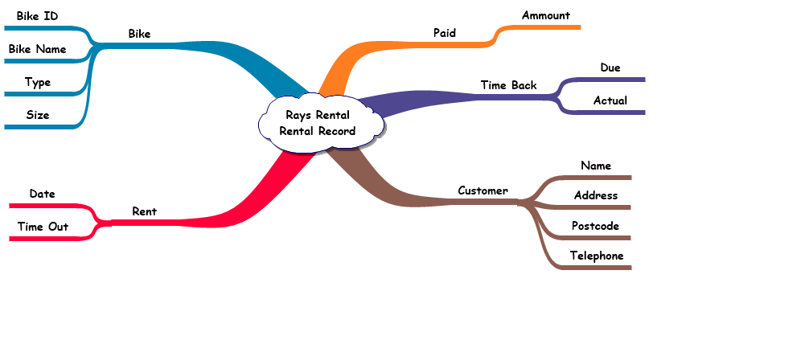Figure 2

### Data enquiries

The database system will have to return required information when given an enquiry, so a search for a bike ID/product code would return all details relevant to that bike: the bike record, maintenance history and all the obvious details like bike class/type, bike size, purchase price and date, manufacturer details.

The DBS must be able to list all bikes and be able to sort them alphabetically, by price, by size and by class. This would come under a product report or stock report.

The Rental Record would have to be displayed in a user friendly and efficient way. Being able to extract data from the DBS and send receipt emails to customers and/or print paper receipts.

### Stock Report

A stock report would be relevant to [RR] Bikes, spare parts. A stock report shows the amount of bikes and bike parts that are available at that time. This will help you to keep track of what you have available at that current time and if you are running low on certain bike parts then you are able to order more in. (See figure 3 for example)

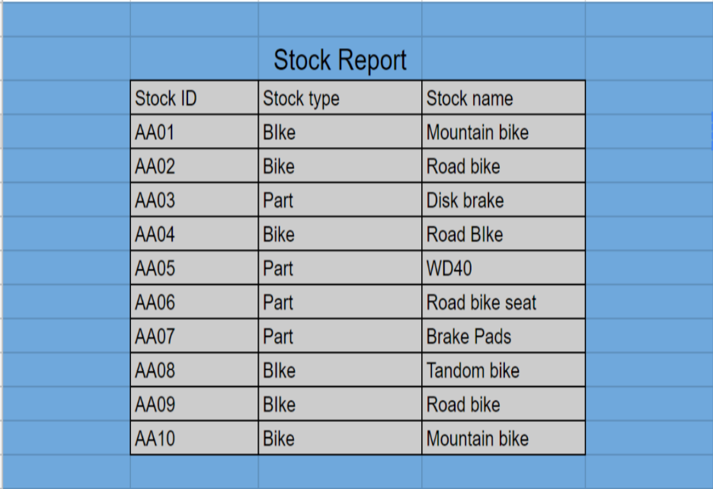

Figure 3

### Damage Report/Maintenance Report

A damage report would be relevant to RR bikes, this would show the damage of all the bikes within the RR shop and what bikes can be used for rental. A stock report is vital to go alongside the damage and maintenance report as then you can order parts to fix bikes which are shown in the damage report.

### Exception Report

Exception Reports (ER). ERs is vital for human staff efficiency in any type of store-organization. ERs goal is to increase overall efficiency in the company-store that it’s added. It’s responsible for warning the suitable staff for problems that might occur so that the right actions will be taken, for checking the company’s-store’s inventory for running low and for controlling the system for anything unusual might happen in companies-store’s systems.

### Financial/Customer Reports

Financial/customer reports these can be combined into one report so that RR can see the arrears of the customers and collect money. They will also be able to see what the profit is like in the current month. This will help the owners decided how to take the business forward to grow the business and keep them open.  (See figure 4 for example)   
  
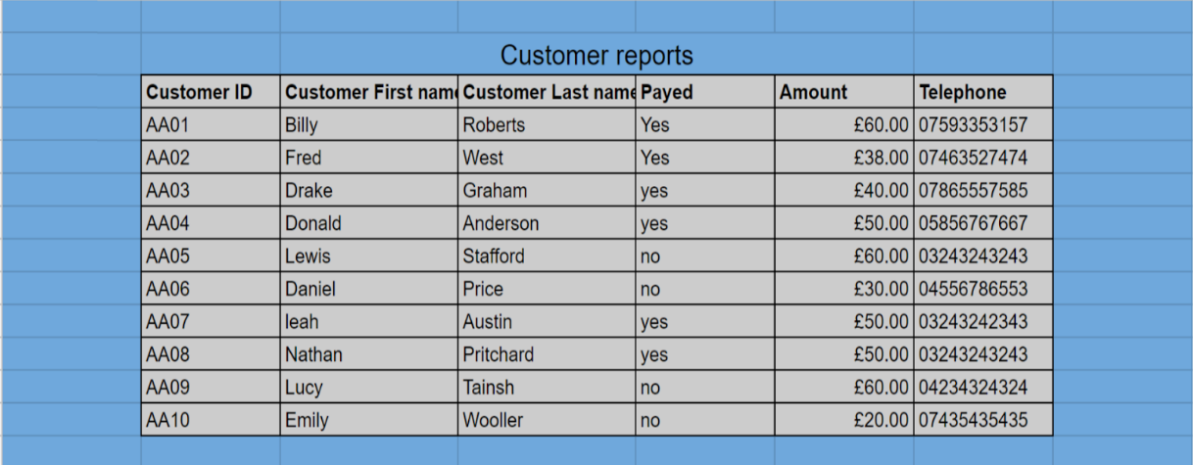

Figure 4

### Analysis Report

In an analysis report, you will look at the data you have gathered throughout the year. A SWOT analysis will be created to act upon business strategy so RR can improve the company.

### Key Target Reports

Key Target Reports show your actual progress compared to your targets progress. These reports will identify whether you have met your targets for the month and the year. It will highlight the targets you have not met in red, which will help you identify which areas you need to work on. This will be beneficial for the business as it will help them keep on the right track and suggest if a new strategy is needed to help reach the targets in future.

## Conclusion

In summary RR’s paper based system has many shortcomings. The proposed new computerised database system will help solve many of these downfalls.

Data enquiries are vital to a database likewise management reports are vital to businesses. The useful reports are outlined above and these would enable RR to build an effective business plan and strategy to move forward, to increase profits, performance and productivity.

---------------------------------------------------------------------------------------------------------------------------

# PART 2

Complete a prioritised group use case diagram (UCD) of the new system (that allows for the activities that take place in the current system), using the ‘MOSCOW’ system of prioritisation.  
  
Provide a commentary explaining the decisions made when creating the UCD and a summary of what has been learned in the process.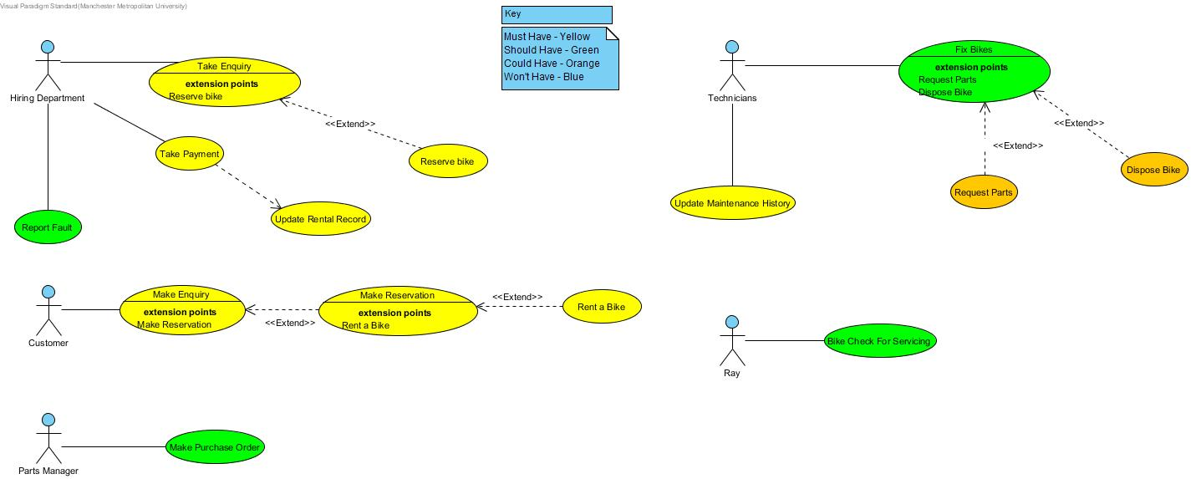

1. Customer Makes a general enquiry via phone, so to get informations about a bike he is interested in. We connected the Actor(Customer) to “Make Enquiry” Use Case“ and we linked it with an extend “Make Reservation” Use Case so when the Hiring Department does it’s work(collect necessary information) Customer can reserve a bike. That’s why we linked “Rent a Bike” as an extend Use Case in “Make Reservation” Use Case.
2. Hiring Department takes the enquiry from the Customer, then collects his details and informs the Customer about the bike he is interested in. That’s why we created a “Take Enquiry” Use Case which is linked with a “Reserve Bike” Use Case in case Customer decides to reserve it. Therefore, if the Customer wants to buy the bike he reserved (or not) he calls Hiring Department proceeds to payment and the Hiring Department updates Rental Record then. That’s why we included “Update Rental Record” connected to “Take Payment” Use Case. Afterall, if Customers have problems with their bikes, they can call Hiring Department and report the problem to them, so the HD with their turn will inform Technicians about.
3. Technicians collects the bikes with their turn and try to fix them. If they need any part for fixing the bikes they have to refer to Parts Manager, That’s why we linked an extended Use Case to “Fix Bikes” Use Case. Otherwise, if they can’t fix the bike, they have to dispose it and inform Ray and the Hiring Department. For that, we linked the “Dispose Bike” Extend Use Case on the “Fix Bike” Use Case. Also, they get the bikes that needs service from Ray who inspects them every Friday.
4. Ray checks all bikes for serving every Friday so they will be ready for sell. If a bike hasn’t been for service for over a month he send it over to the Technicians. We connected “Bike Check for Serving” Use Case to Ray.
5. Parts Manager is responsible for supplying the Technicians with parts when needed for fixing/repairing bikes. We connected “Make Purchase Order” Use Case to Parts Manager.

## Use case diagrams

Complete one use case specification per student (each use case spec should make use of the use case template provided on Moodle and include an entity relationship diagram (ERD)); ensure that you cover the core use cases

By Alexander Harrison

|  |
| --- |
| **Use Case: Bike Check for Servicing** |
| Owner: Ray |
| **Pre-Conditions** |
| Ray will perform the checks on a friday of every week. |
| **Post-Conditions** |
| The bikes will all be checked and then Ray will report it back to the technicians anything that needs to be fixed. |
| **Primary Path** |
| 1. It is a friday 2. The bikes are checked by Ray 3. Ray finds faults 4. Faults are reported to the technicians |
| **Alternate Path** |
| 1. It is a friday 2. The bikes are checked by Ray 3. Ray doesn’t find any faults |
| **Notes** |
|  |
|  |
|  |

By Lewis Frater

|  |
| --- |
| **Use Case: Take Payments** |
| Owner: Hiring Department |
| **Pre-Conditions** |
| Customer has made an enquiry and wants to hire or reserve a bike  The bike the customer wants is in stock |
| **Post-Conditions** |
| If payment is successful, receipt is sent to customer.  Bike gets rented out.  Update rental record. |
| **Primary Path** |
| 1. Customer makes an enquiry via phone 2. Hiring department tells customer bike is in stock 3. Ask for payment details 4. Process payment 5. Send receipt |
| **Alternate Path** |
| 1. Customer makes enquiry via phone 2. Hiring department sends/tells customer bike hiring info 3. Customer decides which bike to hire 4. Ask for payment details 5. Process Payment 6. Send Receipt |
| **Notes** |
|  |

**By Callum Flanagan**

|  |
| --- |
| **Use Case: Take Enquiry** |
| Owner: Hiring Department |
| **Pre-Conditions** |
| Customer contacts Rays Rentals |
| **Post-Conditions** |
| Can lead to handing out information  Can lead to hiring a bike |
| **Primary Path** |
| 1. Customer contacts via phone 2. Customer will ask about a certain bike and gather information 3. Hiring department will check if the bike is available, if so 4. Customer will hire or reserve a bike |
| **Alternate Path** |
| 1. They could email to make an enquiry 2. They can walk into the store to make an enquiry |
| **Notes** |
|  |

**By Callum Flanagan**

|  |
| --- |
| **Use Case: Make Purchase Order** |
| Owner: Parts Manager |
| **Pre-Conditions** |
| Checks parts list |
| **Post-Conditions** |
| Receive bike part and send to technician |
| **Primary Path** |
| 1. Receives information about a fault, 2. Checks to see if the part is in stock 3. If they haven't got the part to fix the bike then order the part . 4. Then the part will be delivered from the supplier 5. The technician will then fix the bike |
| **Alternate Path** |
| Bike is unable to be fixed, therefore the bike will no longer be used.  Then the customer will be informed about the bike. |
| **Notes** |
|  |

**By Rebecca Clarke**

|  |
| --- |
| **Use Case: Fix Bike** |
| Owner: Technician |
| **Pre-Conditions** |
| Bike needs repair, technician receives bike with faults, orders parts and fixes it. |
| **Post-Conditions** |
| Bikes Get Repaired and returned |
| **Primary Path** |
| 1. Technician department is notified of the repair being needed. 2. Technician inspects bike and requests parts for repairs 3. Technician receives parts and fixes bike. 4. Maintenance return bikes |
| **Alternate Path** |
| 1. Technician department is notified of the repair being needed 2. Technician inspects bike 3. Technician has parts in stock 4. Technician fixes bike 5. Technician returns bike |
| **Notes** |
|  |

**By Rebecca Clarke**

|  |
| --- |
| **Use Case: Order Parts** |
| Owner: Techician |
| **Pre-Conditions** |
| Bike needs repair, technician receives bike with faults |
| **Post-Conditions** |
| Parts Manager makes purchase order |
| **Primary Path** |
| 1. Technician department is notified of the repair being needed 2. Technician Receives Bike 3. Technician Inspects Bike 4. Technician tells parts manager which parts he requires |
| **Alternate Path** |
|  |
| **Notes** |
|  |

**By Antreas Christofi**

|  |
| --- |
| **Use Case: Make Reservation** |
| Owner: Customer |
| **Pre-Conditions** |
| Customer calls in and makes a general enquiry for a bike. |
| **Post-Conditions** |
| Ray’s Rentals informs the customer about the bike.  Rental Record checks for bike’s availability.  Hiring Department informs Customer. |
| **Primary Path** |
| 1. Customer calls in and makes a general enquiry for a bike. 2. Ray’s Rentals informs the customer about the bike. 3. Customer decides if he wants to reserve a bike. 4. Reservation details as jotted down from staff along with customer details. 5. Rental Record checks for bike’s availability and informs Hiring Department. 6. Hiring Department informs Customer that his choice of bike is available. 7. Customer Decides if he wants to Reserve a bike. |
| **Alternate Path** |
| 1. Customer calls in and makes a general enquiry for a bike. 2. Ray’s Rentals informs the customer about the bike. 3. Customer decides if he wants to reserve a bike. 4. Reservation details as jotted down from staff along with customer details. 5. Rental Record checks for bike’s availability and informs Hiring Department. 6. Hiring Department informs Customer that his choice of bike isn’t available. |
| **Notes** |
|  |

**By Antreas Christofi**

|  |
| --- |
| **Use Case: Update Maintenance History** |
| Owner: Technicians |
| **Pre-Conditions** |
| Bike has been fixed.  Bike has been serviced. |
| **Post-Conditions** |
| They ask Part Manager for the needed part(s).  They fix the bike.  They update Maintenance History. |
| **Primary Path** |
| 1. Hiring Department informs Technicians for a customers Bike problem. 2. Technicians asks Part Manager for the needed part(s). 3. Technicians fix the bike. 4. They Update Maintenance History. |
| **Alternate Path** |
| 1. Hiring Department informs Technicians for a customers Bike problem. 2. Technicians asks Part Manager for the needed part(s). 3. Technicians inform Hiring Manager that they can’t fix the bike’s problem. 4. They update Maintenance History |
| **Notes** |
|  |

## Top down ERD

Complete a top-down ERD of the system

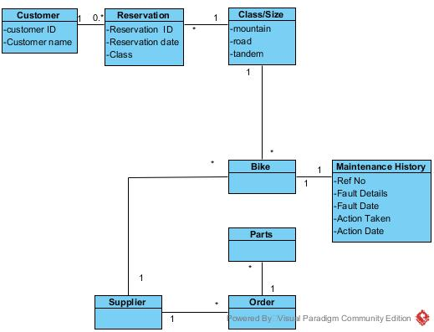

Include a completed RDA of each the two documents provided in the case study and a bottom up ERD of the merged RDAs

### Appendix A - Bike Record

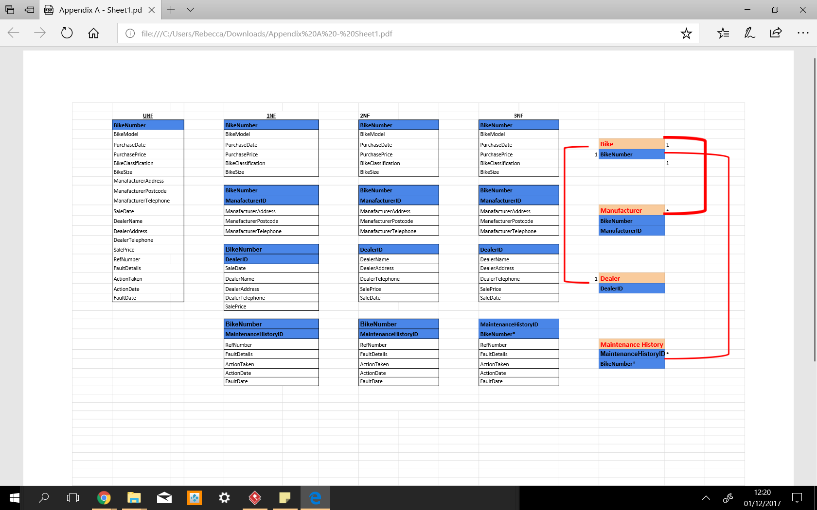

### Appendix B - Rental Record



## Bottom up ERD

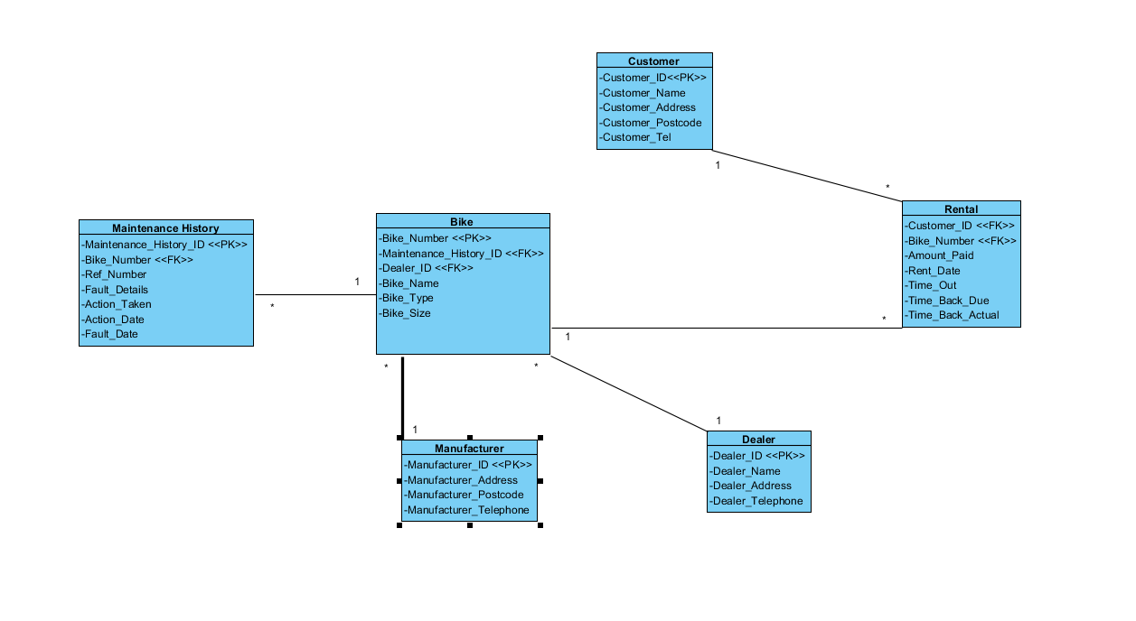

## Finalised ERD

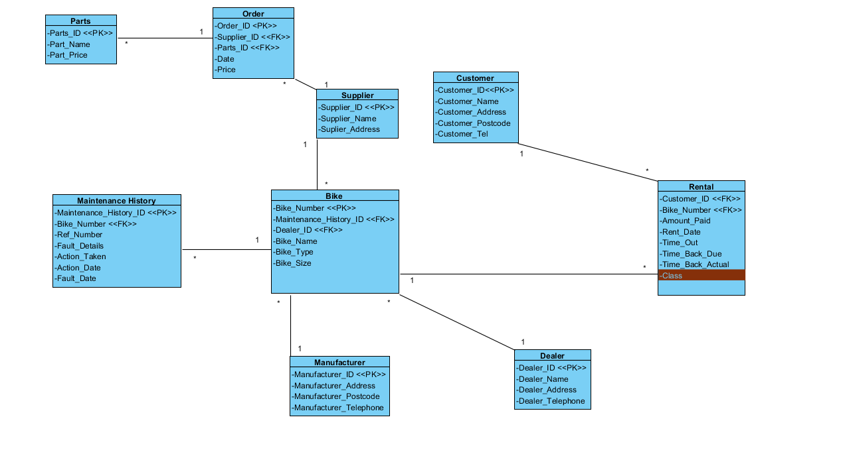

#### Parts to order

We did this so that there wasn’t a many to many relationship and you can see what has been ordered.

#### Order to supplier

We have this so that the supplier will be linked to the order.

#### Supplier to bike

This is to link all the suppliers with the bikes they provide.

#### Bike to Maintenance history

This is where every Technician's work on bikes gets saved so to keep everything sorted.

#### Bikes to manufacturer

This is where the details of every bike’s Manufacturer are kept.

#### Bikes to dealer

This links to every bike’s dealer so his details will be saved.

#### Bikes to rental

Rental links with every bike’s ID so to be easier to inform any Customer about any bike.

#### Rental to customer

This is where Hiring Department informs the Customers about the bike they make an enquiry by giving them all the needed details.

# PART 3

## Amended ERD

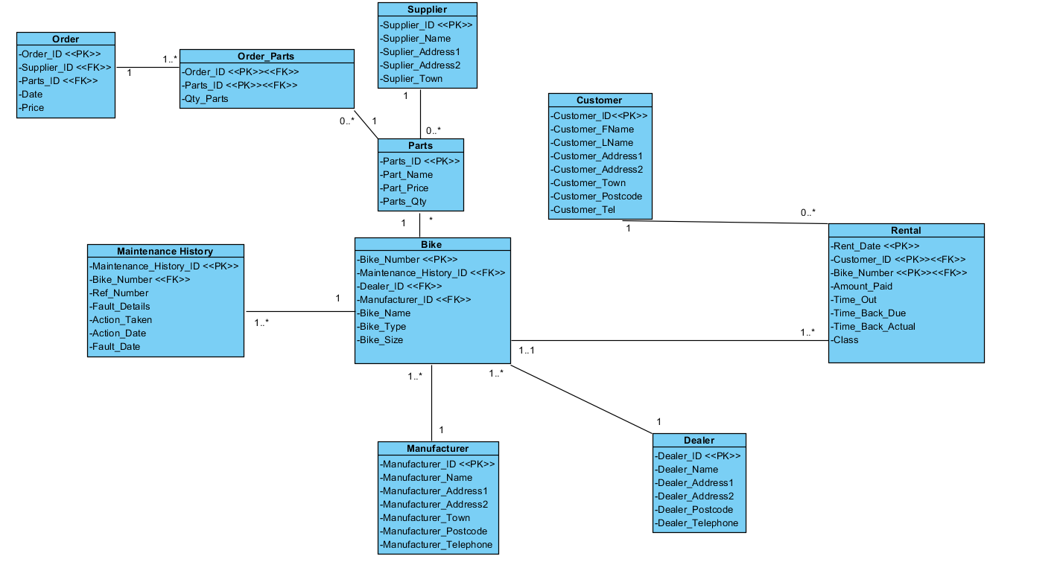

## Data Dictionaries

### Table : Customer

|  |  |  |  |  |  |  |
| --- | --- | --- | --- | --- | --- | --- |
| **Attribute Name** | **Key Type** | **FK Table** | **FK Column** | **Data Type** | **Length** | **Constraint** |
| CUST_ID | PK |  |  | NUMBER | 9 | UNIQUE, NOT NULL,PRIMARY KEY |
| CUST_LNAME |  |  |  | VARCHAR2 | 30 | NOT NULL |
| CUST_FNAME |  |  |  | VARCHAR2 | 30 | NOT NULL |
| CUST_ADDRESS1 |  |  |  | VARCHAR2 | 30 | NOT NULL |
| CUST_ADDRESS2 |  |  |  | VARCHAR2 | 30 | NOT NULL |
| CUST_TOWN |  |  |  | VARCHAR2 | 30 | NOT NULL |
| CUST_POSTCODE |  |  |  | VARCHAR2 | 8 | NOT NULL |
| CUST_TELEPHONE |  |  |  | VARCHAR2 | 15 | NOT NULL |

By Lewis Frater

### Table : Rental

|  |  |  |  |  |  |  |
| --- | --- | --- | --- | --- | --- | --- |
| **Attribute Name** | **Key Type** | **FK Table** | **FK Column** | **Data Type** | **Length** | **Constraint** |
| RENT_DATE | PK |  |  | DATE | DD/MM/YY | NOT NULL,PRIMARY KEY |
| CUST_ID | PK | FK | CUSTOMER | NUMBER | 9 | UNIQUE, NOT NULL,FOREIGN KEY |
| BIKE_NUMBER | PK | FK | BIKE | NUMBER | 9 | UNIQUE, NOT NULL,FOREIGN KEY |
| AMOUNT_PAID |  |  |  | NUMBER | 30 | NOT NULL |
| TIME_OUT |  |  |  | TIME | hh:mm[:ss] | NOT NULL |
| TIME_DUEBACK |  |  |  | TIME | hh:mm[:ss] | NOT NULL |
| TIME_BACBACK |  |  |  | TIME | hh:mm[:ss] | NOT NULL |

By Lewis Frater

### Table : Bike

|  |  |  |  |  |  |  |
| --- | --- | --- | --- | --- | --- | --- |
| **Attribute Name** | **Key Type** | **FK Table** | **FK Column** | **Data Type** | **Length** | **Constraint** |
| BIKE_NUMBER | PK |  |  | NUMBER | 9 | UNIQUE,NOT NULL,PRIMARY KEY |
| MAINTENANCE_HIS | FK | FK | MAINTENANCE_HISTORY | VARCHAR2 | 30 | CHECK,FOREIGN KEY |
| DEALER_ID | FK | FK | DEALER | VARCHAR2 | 30 | NOT NULL,FOREIGN KEY |
| MANUFACTURER_ID | FK | FK | MANUFACTURER | VARCHAR2 | 30 | NOT NULL,FOREIGN KEY |
| BIKE_NAME |  |  |  | VARCHAR2 | 15 | NOT NULL |
| BIKE_TYPE |  |  |  | VARCHAR2 | 15 | NOT NULL |
| BIKE_SIZE |  |  |  | VARCHAR2 | 30 | NOT NULL |

By Rebecca Clarke

### Table : Dealer

|  |  |  |  |  |  |  |
| --- | --- | --- | --- | --- | --- | --- |
| **Attribute Name** | **Key Type** | **FK Table** | **FK Column** | **Data Type** | **Length** | **Constraint** |
| DEALER_ID | PK |  |  | NUMBER | 9 | UNIQUE,NOT NULL,PRIMARY KEY |
| DEALER_NAME |  |  |  | VARCHAR2 | 30 | NOT NULL |
| DEALER_ADDRESS1 |  |  |  | VARCHAR2 | 30 | NOT NULL |
| DEALER_ADDRESS2 |  |  |  | VARCHAR2 | 30 | NOT NULL |
| DEALER_POSTCODE |  |  |  | VARCHAR2 | 10 | NOT NULL |
| DEALER_PHONE |  |  |  | VARCHAR2 | 15 | NOT NULL |

By Alexander Harrision

### Table : Manufacturer

|  |  |  |  |  |  |  |
| --- | --- | --- | --- | --- | --- | --- |
| **Attribute Name** | **Key Type** | **FK Table** | **FK Column** | **Data Type** | **Length** | **Constraint** |
| MANUFACTURER_ID | PK |  |  | NUMBER | 9 | UNIQUE, NOT NULL, PRIMARY KEY |
| MANUFACTURER_NAME |  |  |  | VARCHAR2 |  | NOT NULL |
| MANUFACTURER_ADDRESS1 |  |  |  | VARCHAR2 | 30 | NOT NULL |
| MANUFACTURER_ADDRESS2 |  |  |  | VARCHAR2 | 30 | NOT NULL |
| MANUFACTURER_TOWN |  |  |  | VARCHAR2 | 30 | NOT NULL |
| MANUFACTURER_POSTCODE |  |  |  | VARCHAR2 | 10 | NOT NULL |
| MANUFACTURER_PHONE |  |  |  | VARCHAR2 | 15 | NOT NULL |

By Callum Flanagan

### Table : Maintenance History

|  |  |  |  |  |  |  |
| --- | --- | --- | --- | --- | --- | --- |
| **Attribute Name** | **Key Type** | **FK Table** | **FK Column** | **Data Type** | **Length** | **Constraint** |
| MAINTENANCE_HISTORY_ID | PK |  |  | NUMBER | 9 | UNIQUE,NOT NULL,PRIMARY KEY |
| BIKE_NUMBER | FK | FK | BIKE | VARCHAR2 | 30 | NOT NULL,FOREIGN KEY |
| REF_NUMBER |  |  |  | VARCHAR2 | 30 | UNIQUE,NOT NULL |
| FAULT_DETAILS |  |  |  | VARCHAR2 | 400 | CHECK |
| ACTION_TAKEN |  |  |  | VARCHAR2 | 400 | CHECK |
| ACTION_DATE |  |  |  | DATE | DD/MM/YY | CHECK |
| FAULT_DATE |  |  |  | DATE | DD/MM/YY | CHECK |

By Callum Flanagan

### Table : Parts

|  |  |  |  |  |  |  |
| --- | --- | --- | --- | --- | --- | --- |
| **Attribute Name** | **Key Type** | **FK Table** | **FK Column** | **Data Type** | **Length** | **Constraint** |
| PARTS_ID | PK |  |  | NUMBER | 9 | UNIQUE, NOT NULL,PRIMARY KEY |
| PARTS_NAME |  |  |  | VARCHAR2 | 30 | NOT NULL |
| PARTS_PRICE |  |  |  | NUMBER | 10 | NOT NULL |
| PARTS_QTY |  |  |  | NUMBER | 4 | NOT NULL |

By Alexander Harrision

### Table : Order Parts

|  |  |  |  |  |  |  |
| --- | --- | --- | --- | --- | --- | --- |
| **Attribute Name** | **Key Type** | **FK Table** | **FK Column** | **Data Type** | **Length** | **Constraint** |
| ORDER_ID | PK | FK | ORDER | NUMBER | 9 | UNIQUE, NOT NULL,PRIMARY KEY |
| PARTS_ID | PK | FK | PARTS | NUMBER | 9 | UNIQUE, NOT NULL,PRIMARY KEY |
| QTY_PARTS |  |  |  | NUMBER | 4 | NOT NULL |

By Rebecca Clarke

### Table : Supplier

|  |  |  |  |  |  |  |
| --- | --- | --- | --- | --- | --- | --- |
| **Attribute Name** | **Key Type** | **FK Table** | **FK Column** | **Data Type** | **Length** | **Constraint** |
| SUPPLIER_ID | PK |  |  | NUMBER | 9 | UNIQUE, NOT NULL,PRIMARY KEY |
| SUPPLIER_NAME |  |  |  | VARCHAR2 | 30 | NOT NULL |
| SUPPLIER_ADDRESS1 |  |  |  | VARCHAR2 | 30 | NOT NULL |
| SUPPLIER_ADDRESS2 |  |  |  | VARCHAR2 | 15 | NOT NULL |
| SUPPLIER_TOWN |  |  |  | VARCHAR2 | 15 | NOT NULL |

By Andreas Christofi

### Table : Order

|  |  |  |  |  |  |  |
| --- | --- | --- | --- | --- | --- | --- |
| **Attribute Name** | **Key Type** | **FK Table** | **FK Column** | **Data Type** | **Length** | **Constraint** |
| ORDER_ID | PK |  |  | NUMBER | 9 | UNIQUE, NOT NULL,PRIMARY KEY |
| SUPPLIER_ID | FK | FK | SUPPLIER | NUMBER | 9 | UNIQUE, NOT NULL,FOREIGN KEY |
| PARTS_ID | FK | FK | PARTS | NUMBER | 9 | UNIQUE, NOT NULL,FOREIGN KEY |
| DATE |  |  |  | DATE | DD/MM/YY | NOT NULL |
| PRICE |  |  |  | NUMBER | 15 | NOT NULL |

By Andreas Christofi

## SQL Database Tables (With Insert Statements)

### Create and insert Statement for customer, manufacturer, dealer and bike

### Create and insert statement for Maintenance, rental, supplier and parts

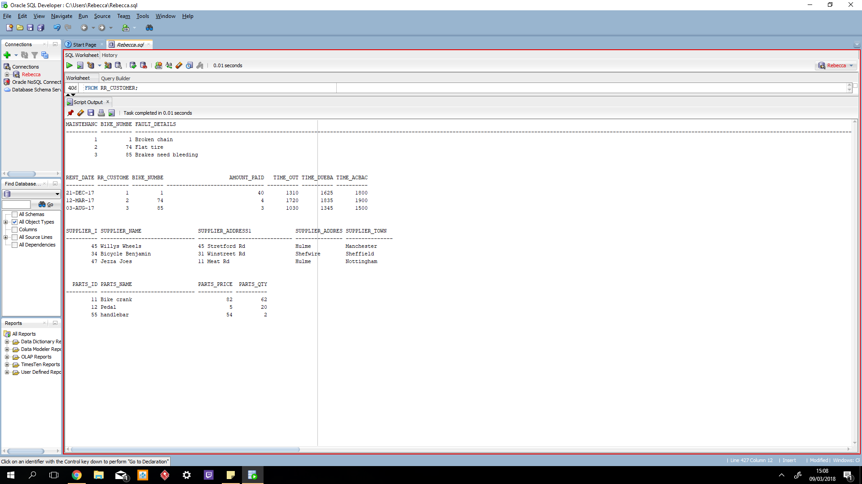

### Create and insert statement for order and order_parts

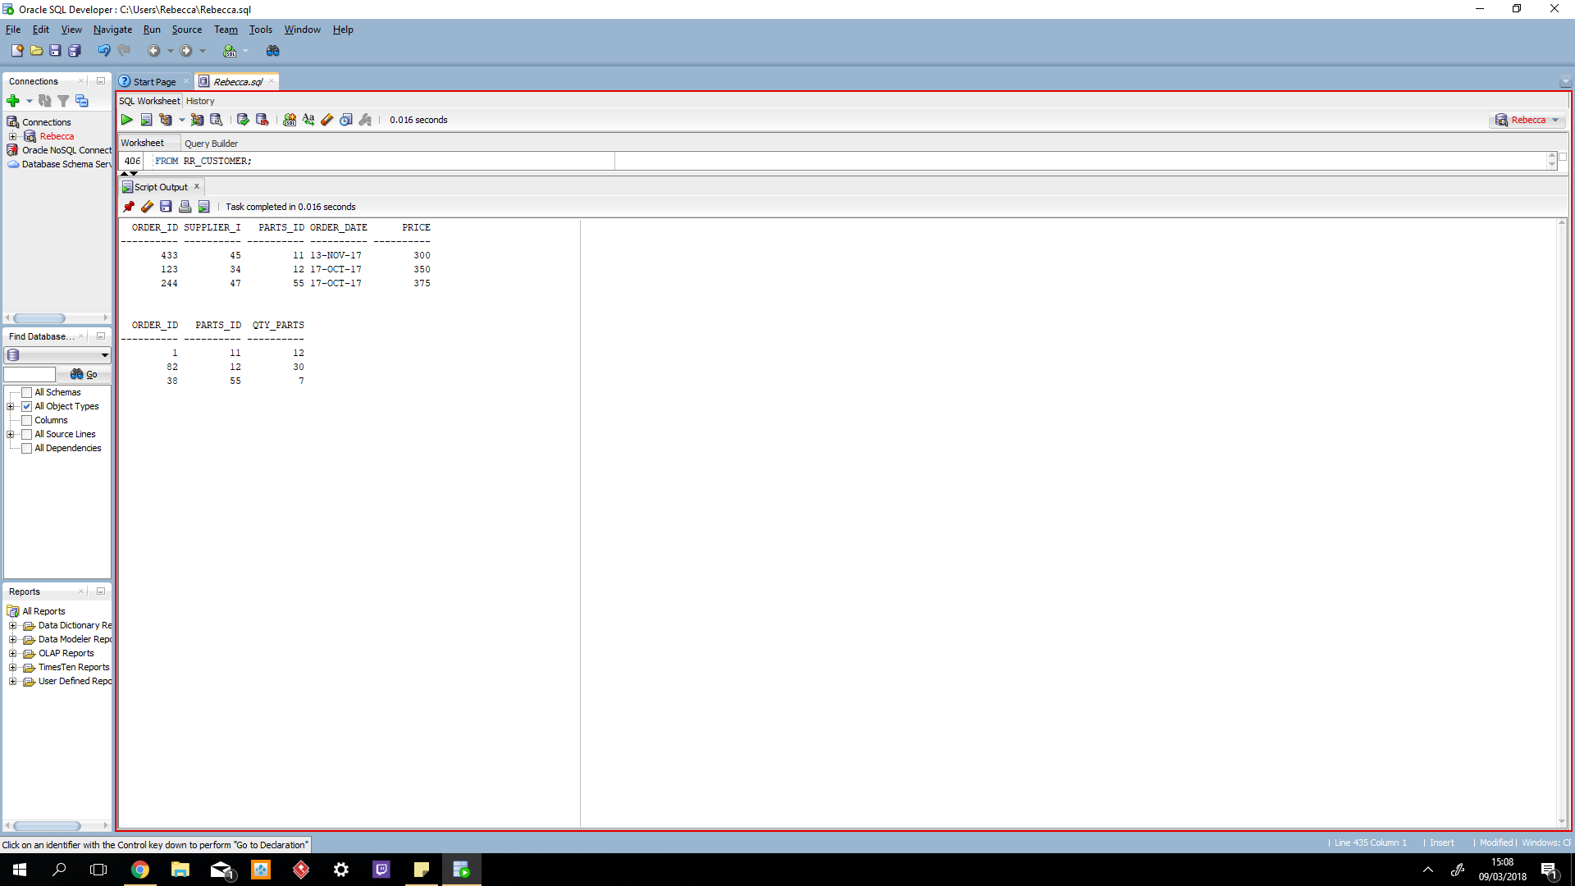

### Drop Tables

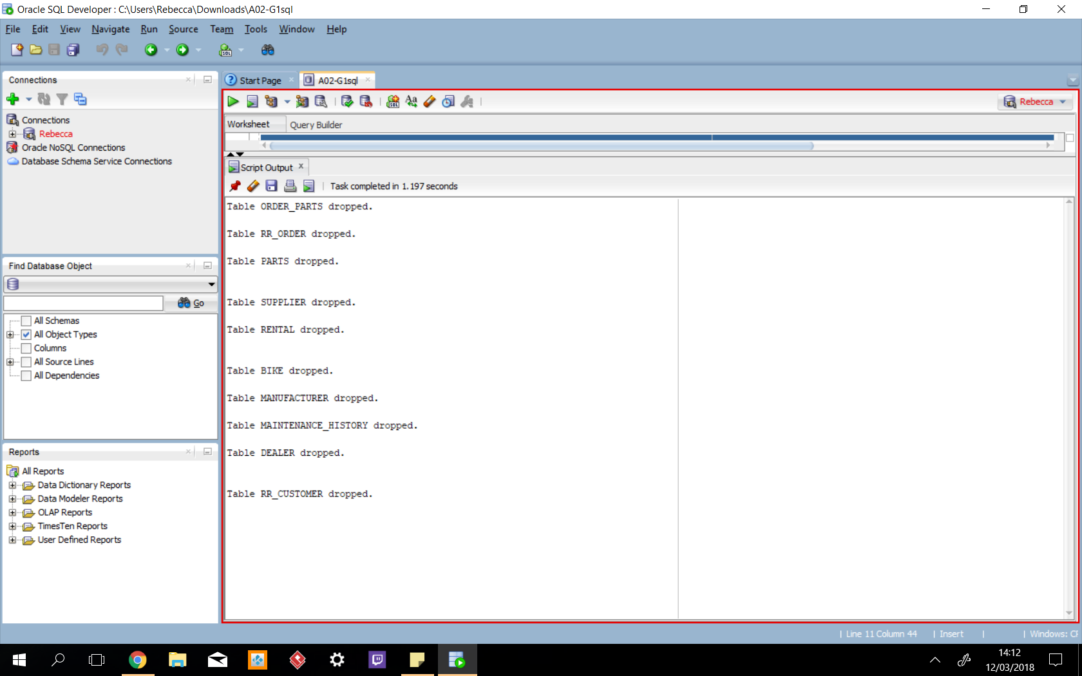

## SQL Queries

### Lewis’s Queries

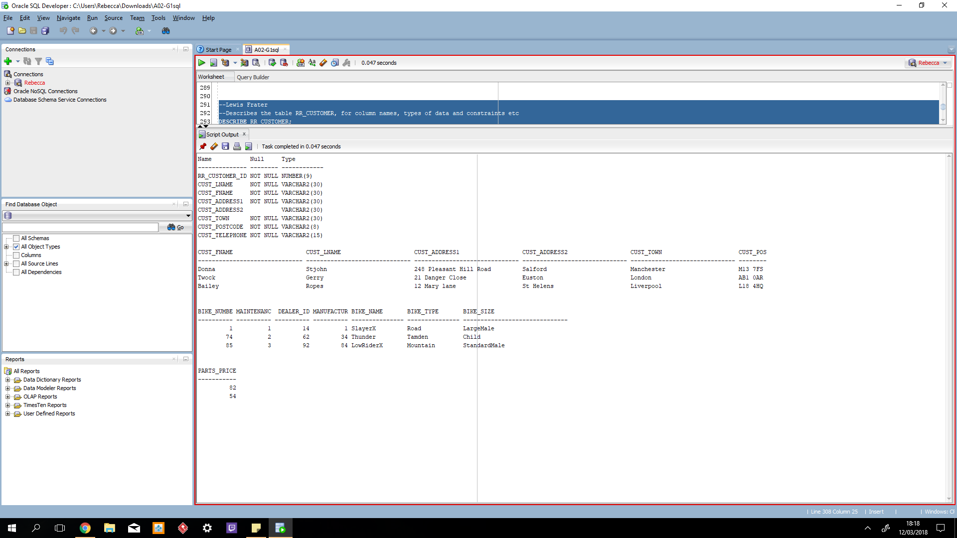

### Alex’s Queries

### Callums Queries

### 

### 

### Andreas Queries

### 

### 

### Rebecca’s Queries

## 

## 

## Commentary

### Lewis Frater Part 3 was interesting because we finally got to implement our ERDs within SQL. Writing the SQL code was quite tricky at first as it was a new language to learn. Putting foreign keys into the tables was a trial and error process as it turned out the order tables are created mattered significantly. This was the initial stumbling block we came across as a group.

### Alexander Harrison

The data dictionaries were easy to do as I have done them before at college and they are very simple to do. When we were working on the SQL for the database we struggled getting the foreign keys working until we realised that the tables had to be created in a specific order and then the sql code became cleared and made it easy to understand.The queries were easy to do wants you understand how they are worded and they make sense after that. Putting the data into the table was a pain as well getting the order correct and getting it set out. We kept running into issues when we created our database that we had to change the ERD for it to work and make sense. We also had a issue that we did not realise you have to drop all of the tables first and then you can actually create the tables.

### Callum Flanagan

First of all we could not implement out ERD so we had to fix that first which was easy as we only had to make minor changes. Once we had fixed out ERD then we could move on to completing out data dictionaries. The data dictionaries were straight forward as i have visited them before. Moving on to the SQL for the data bad was hard as we had trouble putting the foreign keys into the tables. We also found that the certain tables had to be made first in order to make a different table.

### Rebecca Clarke

I found this part of the task, not too bad, we had to fix our ERD after doing the implementation as we found that certain tables had to be changed after we did the SQL code, we also had to figure out a lot of things within SQL such as the correct way to input foreign keys as well as the correct format for time, which we thought was the TIME but turned out to be TIMEDATE. Overall i have learnt about different formats for the type of data, how to implement and fix SQL code, how to communicate effectively within the team to fix the SQL code and ERD, as this is sometimes difficult when trying to clarify what different tables mean and also what is meant by certain elements, for example what is the difference between the manufacturer table and the supplier table.

### 

### 

### Andreas Christofi

Part 3 was a bit difficult on writing the sql code. We had a lot of errors everytime and we had to check every detail every time till we find how to fix everything. We also had a problem on our table’s names because of the already assigned words sql had, like ‘order’ and others. After we went through everything though, I learned how to get over every obstacle and to work and communicate with my team so to make everything work.

# 

# Project Conclusions

### Rebecca Clarke:

As a result of completing this assignment i have learnt alot about system development, such as how to identify problems with a system, what different reports are used within a system, what a UCD is and why it is important as well as why a ERD and RDA are used and why they are important. I have also learnt how to take all the data we have gathered and analysed and how to turn this into a data dictionary using the ERD, then from the data dictionary's how to implement this into Oracle and how to make a database from this using primary keys, foreign keys, their relations between the tables and how to query this in many different ways as well as how to join tables together to show select data from different tables. Overall i feel i have learnt a lot as well as how to work in a group effectively and manage the challenges which often come with group work.

### Alexander Harrison

I found that the Information systems project was hard overall to get people to work together on parts, but we did overall learn how to work as a group. Personally I grew a lot as a person and got more confident of giving out tasks to people for them to do. I found that the work was hard at times as it was confusing and we hit bugs in our code that took ages to fix, working as a group we worked out the bugs and eventually got the code working. We had issues getting our erd to make sense and when we made the database it made us change the erd as it showed us errors that we didn't see.

### Lewis Frater

Information systems has given me a valuable insight on how databases are run for small scale businesses and how they work. The group work has given me a chance to work as a team to achieve common goals and coordinate our work efforts. The introduction of ERD’s has helped me understand a database more clearly than I had imagined before, as well as the use case diagrams. Using SQL was difficult at first, trying to understand how the language operates and how to structure it was irritating. Despite this, I eventually understood SQL, which was a sense of achievement for me. Overall working as a group has helped me to communicate ideas, and to listen to other ideas while being able to choose as a group, the best way forward to tackle problems.

### 

### 

### Callum Flanagan

Overall i have learnt a lot from information systems, i have learnt how to identify problems within a systems that is being used by a business. I have also learnt how to take the current system that is in need of changes and improve it in the best way possible to fulfill the needs of the business. As we moved though each task, i came across new features such as ERD’s which helped me understand how much detail goes into creating a database. I also found out how we use information such as the ERD ect to create data dictionaries which later helped us to convert that into code for implementing data in to the final database that we had to make. In a group we were able to communicate effectively and listen to what each other had to suggest. We split the work up evenly and everyone managed to complete their tasks If anyone was stuck we would work together and help each other to overcome the problem.

### Andreas

After all the time we’ve been through in this class, I’ve learned a vary of things in many sectors. First of all, I learned how to identify any problem and how to be ready to find the solution for it. My group and I got in a big struggle using SQL, as it was a bit hard at first to learn how to use it the right way, but in the end we finally got through it. We learned how to use system and which reports can be used in it. I’ve learned what ERD’s, RDA’s and UCD’s are and why they are so important. I learned how to create tables, how to use primary keys , foreign keys within them, how to create relationships between them and how to join two and three tables. Overall, I learned how to work in a group, how to communicate in a right way and how to overcome every difficulty.

# Referencing List

* S. King, (2016), “Financial Reports vs. Management Reports: What’s the Difference?”  
  (<https://www.growthforce.com/blog/financial-reports-management-reports-differences>)
* T. Jackson, (2016), ”The New Definition of Management Reporting”  
  (<https://www.clearpointstrategy.com/new-definition-management-reporting/> ).

# Bibliography List

* M. [Kolakowski](https://www.thebalance.com/mark-kolakowski-1286589), (2016),“Overview of Management Reporting Systems” (<https://www.thebalance.com/management-reporting-1286950> ).
* M. Tatum, (2017),“What is an Exception Report” (<http://www.wisegeek.com/what-is-an-exception-report.htm> ).

# Appendices

## Appendix A: Piazza report

Date: 09/10/2017

Rebecca: made the mind map

Lewis: wrote up points for question 1

Callum: Contributed ideas

Alex: wrote up points for question 2

Andreas: Contributed ideas

Joe: Tried to contact on MMU email

Reviewed Case study and started mind mapping ideas on each topic, writing out points for question 1+2

Meet up on 11/10/2017 to Discuss Splitting Up Work

---------------------------------------------------------------------------------------------------------------------------

Rebecca:Number 1

Lewis: Number 2

Callum: Number 2

Alex: Number 1

Andreas: Number 3

Joe: - Tried to contact on MMU email

Divided up Work

RC+AH - Number 1

CF+LF - Number 2

AC - Number 3 (Explaining what data enquires and management reports are)

Meet up 13th to discuss work being written up, and any issues we may have.

---------------------------------------------------------------------------------------------------------------------------

Meeting 13/10/2017

Location Library 5th floor

Rebecca: Worked on section 4

Lewis: Worked on section 4

Callum: Put work on the main document then Worked on section 4

Alex: Worked on section 4

Andreas: Worked on section 4

Joe: 2 emails sent to him now and still no response and we have asked around for him in class.

Started putting the work together as a group and we started question 4 as a group

Meet up on 16/10/2017 to work on question 4

Location Library 5th floor

---------------------------------------------------------------------------------------------------------------------------

Meeting 16/10/2017

Location Library 5th floor

Rebecca: Summary

Lewis: Conclusion

Callum: Management reports

Alex: Management reports

Andreas: Question 4

Joe: 2 emails sent to him now and still no response and we have asked around for him in class.

Most of question 4 done, just dividing up the summary, conclusion, and management reports.

Meet up on 17/10/2017 to work on rest of question 4 and summary

Location Library 5th floor

---------------------------------------------------------------------------------------------------------------------------

Meeting 18/10/2017

Location Library 5th floor

Rebecca: Introduction

Lewis: Conclusion

Callum: made mock reports and talked about them

Alex: made mock reports and talked about them and tided document

Andreas: references

Joe: 2 emails sent to him now and still no response and we have asked around for him in class.

Meet on the 20th

Worked together as a group to get it ready for submitting.

Alex is going to submit the work.

---------------------------------------------------------------------------------------------------------------------------

Meeting 20/10/2017

Location Library 5th floor

Rebecca:Sick

Lewis:Edited part 4

Callum: Edited part 4

Alex: piazza report, put the whole submission back together and checked grammar

Andreas: Edited part 2

Joe:2 emails sent to him now and still no response and we have asked around for him in class.

Edited the final submission

Will email to Paris if we can't resubmit

-------------------------------------------------------------------------------------------------------------------------------------

Meeting 20/11/2017 1300 hours

Library 5th Floor

Everybody turned up except Joe. Who we emailed before hand.

Completed 1 and 2, started 3, everyone to complete ERD and UC specs.

next meeting: 21/11/2017 in one hour gaps to complete 3.

--------------------------------------------------------------------------------------------------------------------------------

Late Post for 21/11/17

Reviewed 1+2, asked for feedback on these and needed to re-do this

-------------------------------------------------------------------------------------------------------------------------------------

Meeting 22/11/2017 1300 hours

JD C.012

Everybody turned up except Joe. Who we emailed before hand.

Completed 1+2 In own time

Everyone has been given work for number 3, this will be completed by next meeting

Next Meeting TBA

-------------------------------------------------------------------------------------------------------------------------------------------------------------------

Date 24/11/2017 Time 2:30

2.03

Started the ERD

Attendance: Lewis and Alexander

Absent: Rebecca, Callum and Andreas

Next meeting Monday 3 hour gap

Complete top down and bottom up ERD

---------------------------------------------------------------------------------------------------------------------------------------------------------------------

Date 27/11/2017 Time 3:00

Completed ERD's for use case specs

Attendance : Lewis, Alexander and Callum

Absent: Rebecca, Andreas

Next meeting Tuesday in our hour gaps

Put together ERD's to get a view of the whole system

-----------------------------------------------------------------------------------------------------------------------------------------------------------------------

Date 28/11/2017 Time 1-2 and 3-4

Completed ERD's for use case specs

Attendance: Lewis, Alexander, Callum and Rebecca

Absent: Andreas

Next meeting Wednesday after lesson (1 o clock) in our hour gaps

Put together ERD's to get a view of the whole system.

Date 1/12/2017 Time 1-3

We finished off the ERD and put the remaining work into the report and submitted it.

Attendance

Lewis, Alexander, Callum and Rebecca and Andreas

------------------------------------------------------------------------------------------------------------------------------------------------------

Date 13/2/2018 Time 12-3

We finished data dictionary's and our ERD. Now we are implementing our database design is Oracle.

Attendance: Lewis, Alexander, Callum and Rebecca

Absent: Andreas

-------------------------------------------------------------------------------------------------------------------------------------------------

Date 19/2/2018 Time 1-3

We are implementing our database design is Oracle.

Attendance: Lewis, Alexander, Callum and Rebecca, and Andreas

------------------------------------------------------------------------------------------------------------------------------------------------------

Date 20/2/2018 Time 1-3

We are implementing our database design is Oracle and trying to get our foreign keys to work

Attendance: Lewis, Alexander, Callum and Rebecca, and Andreas

--------------------------------------------------------------------------------------------------------------------------------------------------

Date 21/2/2018 Time 1-3

We finished off our database and started working on queries

Attendance: Lewis, Alexander, Callum and Rebecca, and Andreas

----------------------------------------------------------------------------------------------------------------------------------------------

Date 23/2/2018 Time 12-3

We completed the final bits like inserting information into the table and then finished up the report

Attendance: Lewis, Alexander, Callum and Rebecca, and Andreas

---------------------------------------------------------------------------------------------------------------------------------------------------------

Date 9/3/2018 Time 12-3

Working on the presentation and the report so they are ready for next Friday

Attendance:Lewis, Alexander, Callum and Rebecca

Absent: Andreas

Date 12/3/2018 Time 1-3

Working on the presentation and the report so they are ready for next Friday

Attendance: Lewis, Alexander, Callum and Rebecca

Absent: Andreas

## Appendix B: Presentation Slides

